**Cyrus Peirce Middle School**

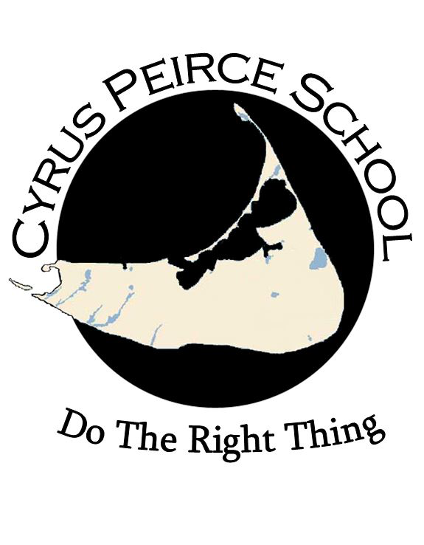

**School Improvement Plan, 2023-2024**

### 

**Directory**

Elizabeth Hallett, Ed.D. – NPS Superintendent

**Cyrus Peirce School Council**

Michael Horton - Principal

Adriene Lombardi - Assistant Principal

Meg Browers - Parent

Jess Douglas - Parent

Stacy Montes - Parent

Michael Case - Teacher

Mark Gonnella - Teacher

Emmeline Browers - Grade 8 Student

### [***Return to District Improvement Plan (DIP)***](https://docs.google.com/document/d/1ycduHnqYVsEplF9HSYSpANaHiZEzzuDNP6eWaoHudLc/edit?usp=sharing)

**Message from the Principal and Assistant Principal**

* Our vision is that CPS creates an equitable, inclusive, and challenging learning environment for young adolescents to develop skills that foster independence, build student voice, and strengthen decision-making to ‘Do the Right Thing.’
* We hope that students are motivated to learn, thrive emotionally and socially, and participate in school and community activities. The CPS staff is dedicated to building strong relationships with families and island organizations to support student growth and learning at home, in school, and within the community. Building these relationships requires consistent communication in order to inform families of student progress and growth. The CPS School Council has been formed to develop, monitor, and sustain communication between school and home. One step in maintaining that communication is the *CPS Weekly Parent Update*. This Monday evening ‘Smore’ newsletter contains important information ranging from announcements, schedules, and events, to articles, parent support groups, and celebrations.
* This year our school will be adopting Responsive Classroom by reinforcing and practicing important skill sets of social emotional competencies: cooperation, assertiveness, responsibility, empathy and self-control as well as an academic mindset of perseverance. Through Responsive Classroom and best teaching practices, students will also be learning strategies and academic behaviors that will help them through these adolescent years.
* We have a strong team of teachers and support staff to help guide our students to gain independence and build their student voice. We are here to support our CPS families and look forward to a great school year!
* Michael Horton Adriene Lombardi   
  CPS Principal CPS Assistant Principal  
  hortonm@npsk.org lombardia@npsk.org  
  508-228-7283 x1401 508-228-7283 x1403

| NPS Strategic Objectives | | |
| --- | --- | --- |
| **1: Increase Student Outcomes and Achievement** by providing equitable, inclusive and challenging learning experiences through a comprehensive system of support. | **2: Secure and Maximize Resources** that meet the growing needs of the district by providing a sound budget process, intentional staff recruitment and retention, comprehensive maintenance of facilities, and access to advancements in technology. | **3: Nurture a Culture of Inclusion, Collaboration, and Communication** by recognizing and celebrating the uniqueness of all individuals (students, educators, families, and the community alike) and cultivating socially responsible members of diverse local and global communities. |
| NPS Strategic Initiatives | | |
| * 1.1 Successfully implement and continually assess the effectiveness of the established curriculum, instructional, and assessment practices. * 1.2 Define, implement, and support high-impact, tiered pedagogical practices that are culturally and linguistically appropriate, universally designed, and foster academic, behavioral, and social-emotional learning for all learners. * 1.3 Optimize and strengthen school safety processes and protocols across the district through proactive evaluation, adjustment, and alignment. | * 2.1 Ensure sustainable sources of revenue for facilities, infrastructure, and operational expenses. * 2.2 Actively promote a diverse, high-quality workforce and expand housing inventory for staff to support their recruitment, development, and retention. * 2.3 Maintain and upgrade district facilities and grounds. * 2.4 Secure and maximize resources within the district (i.e., schedules/staffing/ technology) to meet growing needs, enhance educational outcomes, and support efficient operations. | * 3.1: Foster a sense of belonging and community to strengthen partnerships with students, staff, families, and the wider community. * 3.2 Cultivate a stronger sense of community and positive culture among district staff. |

| CPS Vision and School Improvement Plan Goals, 2023-24 | | | |
| --- | --- | --- | --- |
| VISION | | | |
| CPS creates an equitable, inclusive, and challenging learning environment for young adolescents to develop skills that foster independence, build student voice, and strengthen decision-making to ‘Do the Right Thing.’ | | | |
| Goal | Action Steps | Outputs | Outcomes |
| During the 2023-24 school year, CPS will reduce the number of students in the ‘Not Meeting’ tier of each MCAS subject test to below 15%. (1.1, 1.2) | * Data Driven PD day September 2023 to analyze 2023 MCAS results. * Implement MAP reading and MAP math assessments 3x per year. * Year 2 of Guided Math/Math Workshop model. * Co-teaching for Entering EL students in the areas of math and science. * Co-teaching for special education students. * Hire a math intervention teacher. * Increase after school tutoring and extra help opportunities. | * Teachers analyze student data to improve instruction. * Observations, discussions, and feedback with math coach, Alison Mello. * Common planning between co-teachers. * Identify and schedule students into small group math sections. * Identify and motivate students to attend evening and Saturday extra help sessions. | Student achievement improves. (MCAS and MAP) |
| By June 2024, CPS will continue to prioritize and implement student choice and voice as part of the Universal Design for Learning practices by making adjustments in lessons and teaching practices as measured by walkthroughs, peer observations, and observations. (1.2, 3.1) | * Teacher PD in UDL principles. * Students join the School Council. * Students present at CPS staff meetings. * Teachers share academic choice opportunities with colleagues during planning time and EWD meetings. | * Teachers offer multiple means of engagement, representation, and expression in CPS classrooms. * Students have choices in their learning (different ways to complete assignments and express themselves.) * Students have participation in school decisions, handbooks, and committees. | * Improved school culture as evidenced by fewer student discipline referrals and suspensions than the 2022-23 school year. * Improved staff and student sense of belonging as evidenced by increased staff participation in workgroups, school events, and spirit week themes. * Increase UDL practices and student engagement in each classroom. * Student achievement improves. * (MCAS and MAP) |
| By June 2024, CPS will continue to focus on improving school culture and morale through mentoring, coaching, and collaboration. (3.2) | * Updated mentoring program. * Math coach works with CPS teachers. * Co-teaching professional development * Staff committees formed for:   + Culture & Climate   + Grading   + Scheduling   + Responsive Classroom   + Budget | * Mentors are assigned and teachers meet with mentors. * Math coach visits classrooms and provides follow-up coaching. * Co-teachers meet together to plan lessons, review student work, and reflect to make adjustments in future lesson plans. * Committees are formed and meet at least once per month | * A higher percentage of teachers return to CPS for the 2024-25 school year than in recent years. * Student achievement improves. (MCAS and MAP) * Improved school culture as evidenced by survey data and a decrease in discipline referrals |
| By June 2024, CPS teachers will complete Responsive Classroom professional development that results in CPS students reporting an increase in their sense of belonging as measured by end-of-year student survey data. (1.1, 1.2, 1.3, 3.1, 3.2) | * Responsive Classroom training (Aug, Oct, Nov ) * Implement RC strategies and protocols within every CPS classroom environment * Staff collaborate and share best practices and strategies during team meetings and extended work days. | * Teachers build positive classroom communities * Teachers embed effective management to the unique needs of young adolescents. * Faculty meeting agendas and notes. | * School promotes strong academic and social emotional skill building. * Increased focus on student engagement in extended homeroom advisories. * Improved staff and student sense of belonging as evidenced by survey data and decrease in discipline referrals. |